Digital Control Systems (05/03/2019)

**Project** **Proposal**

Simulation Study of Cruise Control

Department of Electrical Engineering

王喻民(R07921009)、林柏宇(R07921070)

1. **Introduction**

Cruise control is a system that automatically controls the speed of a vehicle. There are some advantages of cruise control:

1. Reducing driver fatigue.
2. Avoid subconsciously violating speed limits.
3. Increased fuel efficiency.
4. **Purpose**

We want to implement the simulation of automatic cruise control. Our purpose is to maintain a constant vehicle speed despite external disturbances, such as changes in wind or road grade.

1. **Methods**

We plan to achieve this purpose by measuring the vehicle speed, comparing it to the desired or reference speed, and automatically adjusting the throttle according to a control law.

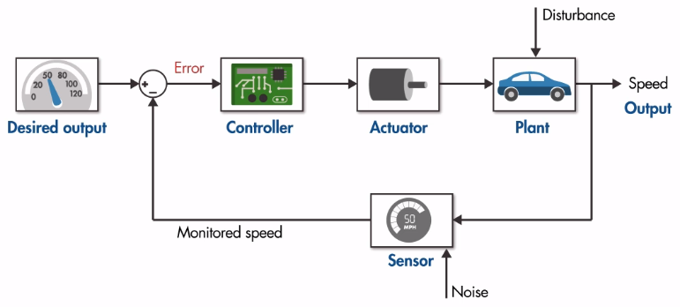

<https://www.mathworks.com/videos/understanding-control-systems-part-3-components-of-a-feedback-control-system-123645.html>